HEIDENHAIN solutions at AMB 2024: the next step to machine-tool sustainability

How far along are machine-tool users and OEMs on the path to sustainability? What steps could they take to reduce their carbon footprint and total cost of ownership (TCO)? “Stairway to sustainability: more productivity from the first part” is the HEIDENHAIN motto at its AMB trade show exhibit, where visitors will find a variety of solutions that unlock greater productivity, quality and process reliability.

Greater productivity through context-sensitive guidance:
The new hardware versions of the HEIDENHAIN TNC7
Thanks to its new hardware versions spanning three different monitors (24-inch, 19-inch and 16-inch) and two different keyboards, the TNC7 from HEIDENHAIN can be adapted to a wider range of applications. Our focus at AMB 2024 is on the 16-inch-monitor version, called the TNC7 basic. Designed to replace the TNC 620, this new variant lies toward the lower end of the TNC7 portfolio, where it delivers powerful TNC7 benefits to 3+2-axis machines. Highlights shared with other TNC7 controls include its Full HD monitor and access to an extensive suite of software options. Options such as MAS graphical 6D setup support, DCM collision monitoring and OCM trochoidal milling contribute to the control’s next-generation user-friendliness, efficiency and process reliability.

Innovative Digital Software Software solutions:
The latest version of StateMonitor with energy monitoring and ERP interfacing features
The StateMonitor machine data collection software from the HEIDENHAIN Digital Shop Floor provides real-time insight into the production status of your CNC machines. To this end, StateMonitor collects, analyzes and visualizes machine data such as machine statuses, tool data, NC program runtimes and PLC signals. The latest software version can now also analyze detailed data about how much power, compressed air and process water machines are consuming. This information can then be used to undertake optimizations. What’s more, to improve process efficiency in a digital ecosystem, a new ERP interfacing feature enables automatic data sharing with higher-level ERP and MES systems. The new HEIDENHAIN StateMonitor software version delivers greater operational visibility for your shop floor.

Three roles in one system for holistic tool inspection:
The HEIDENHAIN VT 122 measuring camera with smart VTC software is making its global debut at AMB
The new VT 122 measuring camera with the VTC software from HEIDENHAIN performs three roles in a single system, providing an all-in-one tool presetter, tool microscope and visual inspector. Instead of taking tools to the metrology lab, users can inspect tool edges using images taken inside the machine envelope. This system provides the facts needed for holistic tool analysis. With the combined intelligent features of the VT 122 vision system and VTC software, a tool’s length and diameter can be measured in an automated process. The images taken also permit manual tool-wear measurements and detailed tool inspection. Users benefit from the following: a significant increase in productivity; prolonged tool life and therefore lower TCO; and automated, reproducible documentation about wear and overall tool condition.

More available cutting time and greater process reliability:
The TD 110 tool breakage detector from HEIDENHAIN
Perform on-machine tool breakage inspection that seamlessly integrates into your automated processes. The HEIDENHAIN TD 110 tool breakage detector provides two essential sustainability benefits: significant time savings and minimized scrap. The TD 110 accelerates tool inspection by up to six seconds every time a tool change occurs. Its sensor identifies broken tools on their way back and forth between the tool magazine and the machine envelope. Nearly any machine tool can be retrofitted with the TD 110, where is it positioned near the machine table within the machine envelope.

Perfect scale readings without purge air:
HEIDENHAIN encoders with innovative True Image technology can reduce your carbon footprint by 99%
The use of coolant during machining causes condensation and liquid contamination in the machine tool. But the HEIDENHAIN LC and LB linear encoders and the RCN and ECA angle encoders deliver clear scale readings despite contamination. Their True Image technology is so dependable that, in many cases, these encoders can be operated without purge, thereby simplifying the machine’s purge air system. Users can leverage the benefits of closed-loop position feedback with an up to 99% smaller carbon footprint and considerably lower system costs.

HEIDENHAIN at AMB, Sept. 10 to 14, 2024

Main booth:  Hall 2, Booth 2D10 | TNC Club:  Hall 2, Booth 2B03
Training Exhibit:  East Entrance, Atrium | HEIDENHAIN @ DMG Mori:  Hall 10, Booth 10D10
For more information, visit:  live.heidenhain.com  www.heidenhain.com/tnc7  www.heidenhain.de | Contact person for the trade press:  Ulrich Poestgens  DR. JOHANNES HEIDENHAIN GmbH  Dr.-Johannes-Heidenhain-Straße 5  83301 Traunreut, GERMANY  Tel.: +49 8669 31-4154  poestgens@heidenhain.de

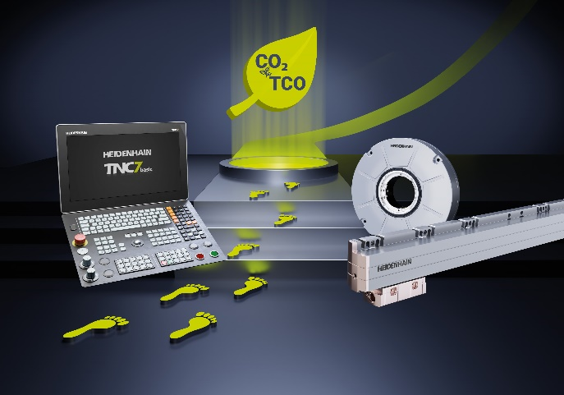 | HEIDENHAIN at AMB 2024: sustainable solutions for machine-tool users and OEMs provide a smaller carbon footprint and lower TCO
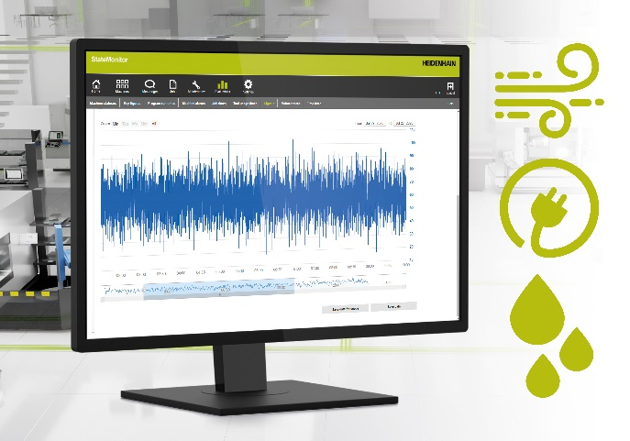 | Now equipped with energy monitoring and an ERP interfacing feature: The StateMonitor machine data collection software from the HEIDENHAIN Digital Shop Floor
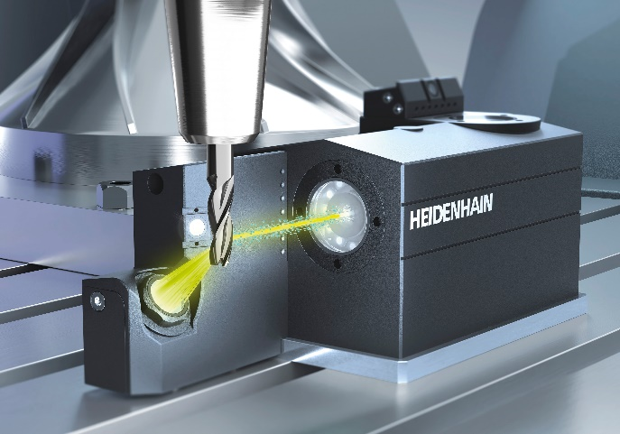 | Three tasks in one machine-tool inspection solution: magnify, inspect and preset with the VT 122 measuring camera and intelligent VTC software
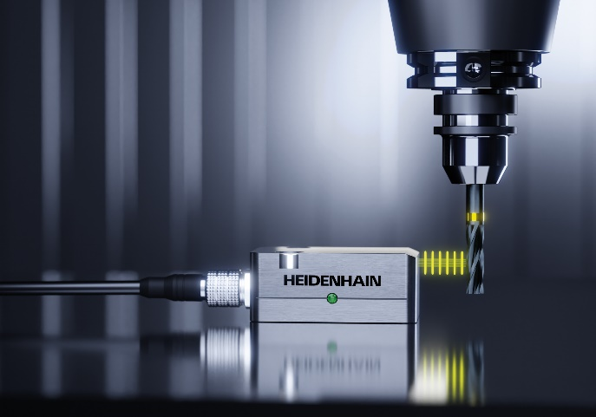 | Save six seconds during each tool breakage inspection: the TD 110 tool breakage detector from HEIDENHAIN provides fast, on-machine inspection, even for microtools
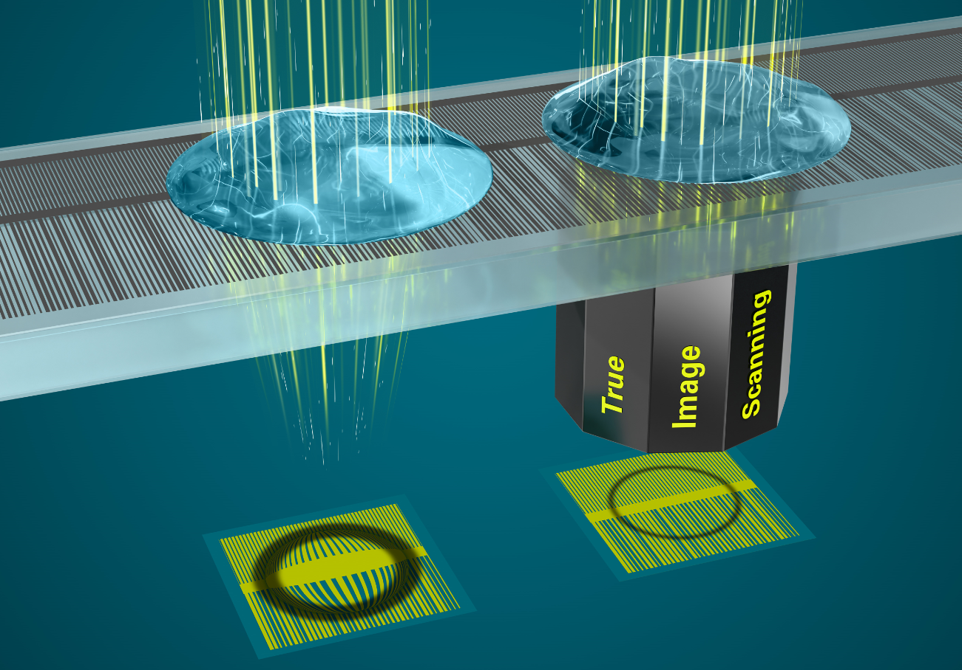 | Reduce your carbon footprint and TCO: Equipped with True Image technology, HEIDENHAIN encoders deliver high-accuracy position feedback without purge air

